William T. Williams

American, b. 1942, Cross Creek, NC, lives in New York, NY

As a part of his graduate studies at Yale in 1968, Williams proposed the Artist-in-Residence (AIR) Program to the organization that was to become the Studio Museum in Harlem and in doing so, gave the museum its name. Over forty years later, the program has been host to numerous successful artists such as Chakaia Booker, David Hammons, and Tyrone Mitchell. In the tradition of community activism, the museum was founded to provide artists in the urban center of African-American culture a place for greater discourse that was not being provided by the mainstream Euro-centric art communities.

Williams has been a distinguished voice in the dialogue surrounding the re-contextualization of the role of African American art in the Western art canon. A professor of painting at City University of New York since 1971, he is instrumental in creating a platform that enables young artists the opportunity to challenge the existing hegemony of American art.

Williams discussed the role of the AIR program at the Studio Museum in Harlem in 2006:

*“Part of the infrastructure is certainly the contribution of this museum as a training ground for so many of those who have gone on and now are in a place where they can make a difference. It took that many years to begin to put all of the infrastructure in place. The future is that – it’s the future, where a lot of these things will be unraveled. The body of work is there, it’s just a question of time. Art history is one of those things that’s constantly being reassessed and rewritten.” 1*

Williams’ work can be found in the permanent collection of institutions such as the Museum of Modern Art and the Whitney of American Art in New York, as well as the Yale University in New Haven, Connecticut.

1 Williams, T. William. “Energy/Experimentation: Black Artists and Abstraction, 1964-1980.” Black Artists and Abstraction: A Roundtable. New York: Studio Museum in Harlem, 2005 (82).

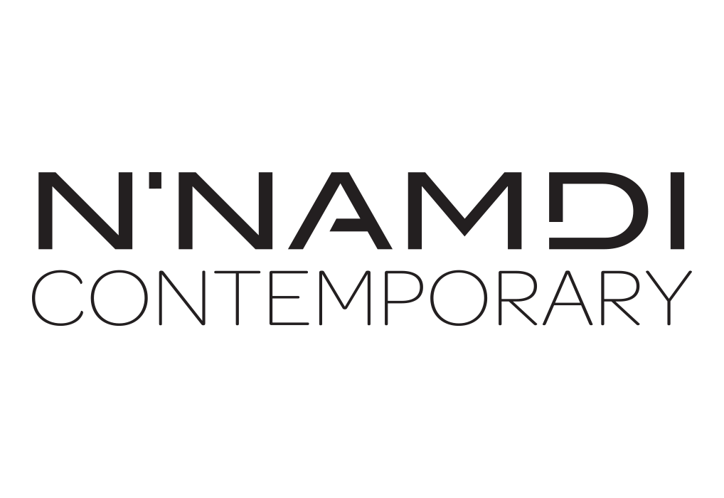

For further inquiries contact the N’Namdi Contemporary Fine Art Gallery  
786-332-4736 | 177 Nw 23rd St. Miami, Fl 33127 | [www.nnamdicontemporary.com](http://www.nnamdicontemporary.com)