

**VICENTE PIMENTEL.**

He plays the role of the middleman while he communicates memories of his native land and historical grounds onto a canvas. By creating his own natural inks from different soils he has collected throughout the world he is able to literally make his work from scratch. These unique inks are used to create layers of textured stains on paper and canvas. Giving each piece an organic connection that meets an aesthetically pleasing nature. Born in Santo Domingo in 1947, he now currently lives and works in Paris, France. He studied at the National school of Fine Arts in Santo Domingo and at L’ecole D’ Art and Architecture in France. He obtained the prize “Ville de Virtry” in France in 1982. He has public collections in several places such as the Museum of Art & Technology in Florida, The National Museum of Modern Art in Santo Dommingo, The Fonds National D’Art Contemporian in Paris and the Pompidou Collection. He also has individual exhibitions in New York, Chicago, Paris, Stockholm, and his hometown. Collectively he is in such places like Madrid, Paris, Stockholm, Canary Island, London, Havana, Rijeka (Yugoslavia), Nice and Copenhagen.

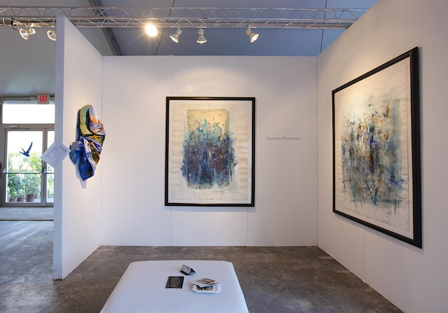

Untitled/ Garden Series Untitled/Garden Series  
Mixed Media on Canvas Mixed Media on Canvas  
51 ½” x 64” 51 ½” x 64”

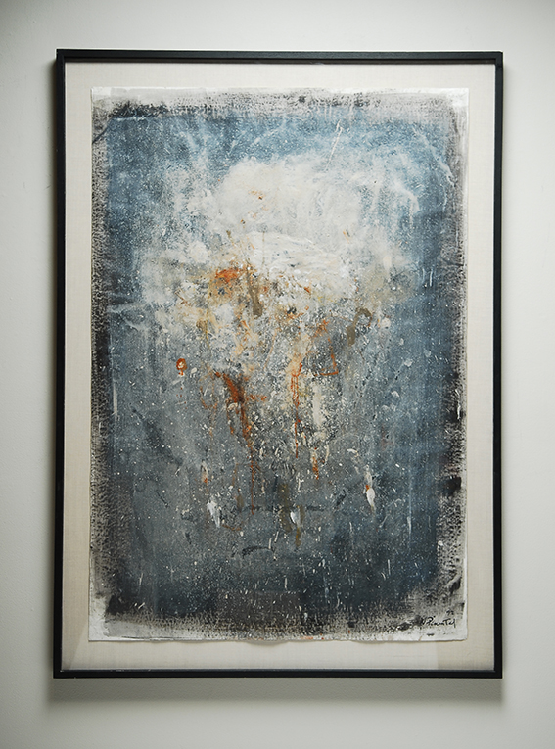

Untitled  
Mixed Media on Canvas  
47” x 66”

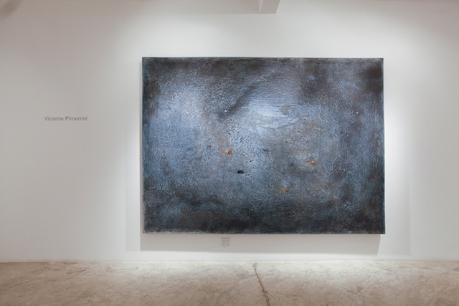

Untitled  
Mixed Media on Canvas  
118” x 86”

177 NW 23rd ST, Miami, FL 33127 | 786-332-4736