Tyrone Mitchell

American, b. 1944, Savannah, GA, lives in New York, NY

Tyrone Mitchell uses natural materials and modernist tenets to create sculpture that relates to African Diaspora. After his studies at the New York Studio School and Art Students League, he traveled to West Africa in 1969. He became acquainted with the cultures of the Dogon people of Mali and the Yoruba of Nigeria. This exposure to his ancestral land became extremely influential in the development of his art.

In 1980, the artist returned to his birthplace of Savannah and began an artist-in-residency in the Georgia Sea Islands. Currently, a government owned nature preserve, during the eighteen century (specifically the island of Ossabaw), was used as a slave trading and holding center until the American Civil War. The island’s history became an intrinsic part of his work.

A recipient a Guggenheim Fellowship and The New York Foundation for the Arts Fellowship, Mitchell’s artwork has been exhibited at major institutions including The Metropolitan Museum of Art, The Studio Museum in Harlem and El Museo de Artes Visuales in Venezuela.

*“I think the period divided people down the middle in terms of who was “really” a black artist – an artist whose work reflected the political environment in a specific way. If you look at the work of the sixties, there were people whose work represented specifically the social situation. But there were a lot of artists whose work, before and after that period, was primarily abstract and there was no element in that work that was palatable to the movement. I think a lot of those black artists suffered. A lot of them stopped making art.” 1*

Tyrone Mitchell, 1990

1 Wright, Beryl J. “Tyrone Mitchell.” New Jersey: Newark Museum, 1990 (7).

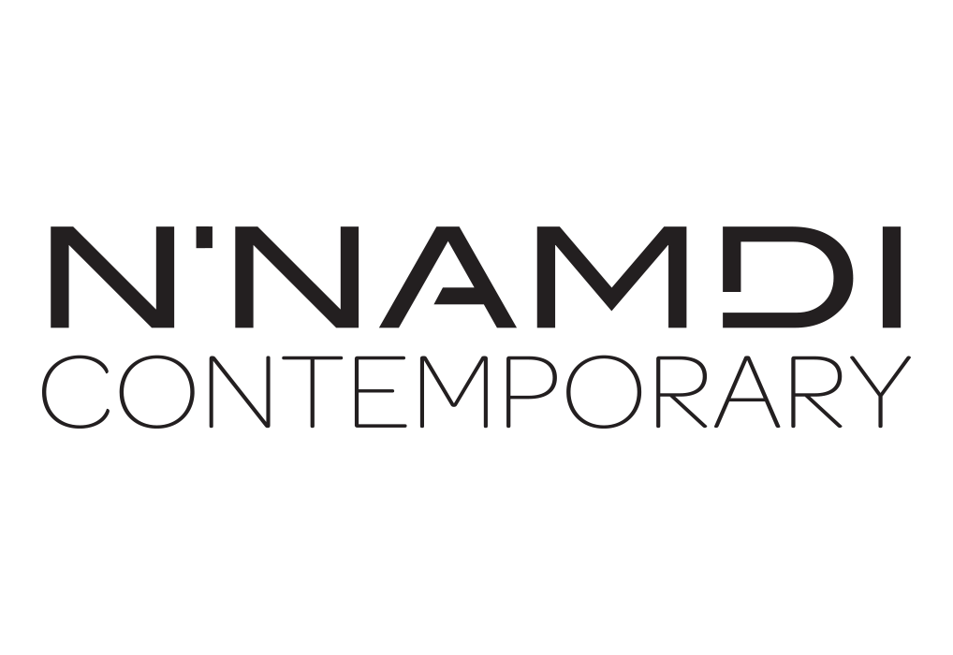

For further inquiries contact the N’Namdi Contemporary Fine Art Gallery  
786-332-4736 | 177 Nw 23rd St. Miami, Fl 33127 | [www.nnamdicontemporary.com](http://www.nnamdicontemporary.com)