Bill Hutson

American, b. 1936, San Marcus, TX, lives in Lancaster, PA

After serving in the U.S. Army from 1954-1957, Hutson moved to California settling in San Francisco in 1959. The area offered potential for the artist to explore his interests in art from a more formal perspective. Largely self-taught, he began creating abstract canvases incorporating found objects to considerable success. His art was purchased by the San Francisco Museum of Modern Art in 1961. The importance of travel and migration from one location to another is extremely significant to the artist’s development. For almost fifteen years he traveled throughout Europe living in France, Holland, and Africa, returning to United States in 1977.

During the early seventies, Hutson sublet an apartment in SoHo and befriended his neighbor, Al Loving. This connection to the New York art scene and the emerging Black Nationalist Movement encouraged socialization with other African-American artists working within the tenets of abstraction. Hutson creates depth by layering richly blended gestural surfaces that contain precise geometric forms. The ground for this series of work is achieved by pouring acrylic paint on a painted surface to which a plastic sheet and weighted board are applied. After the paint dries, the board and plastic are removed. Hutson then applies tape and additional layers of acrylic to achieve abstract harmonies.

In 2008, Hutson curated Something to Look Forward To: Abstract Art by 22 Distinguished Americans of African Descent, in conjunction with the Phillips Museum of Art at Franklin & Marshall College in Lancaster, Pennsylvania. The exhibition featured artists over sixty-years-old that included Frank Bowling, Ed Clark, Sam Gilliam, David Hammons, Al Loving, Richard Mayhew, Howardena Pindell, John T. Scott, and William T. Williams.

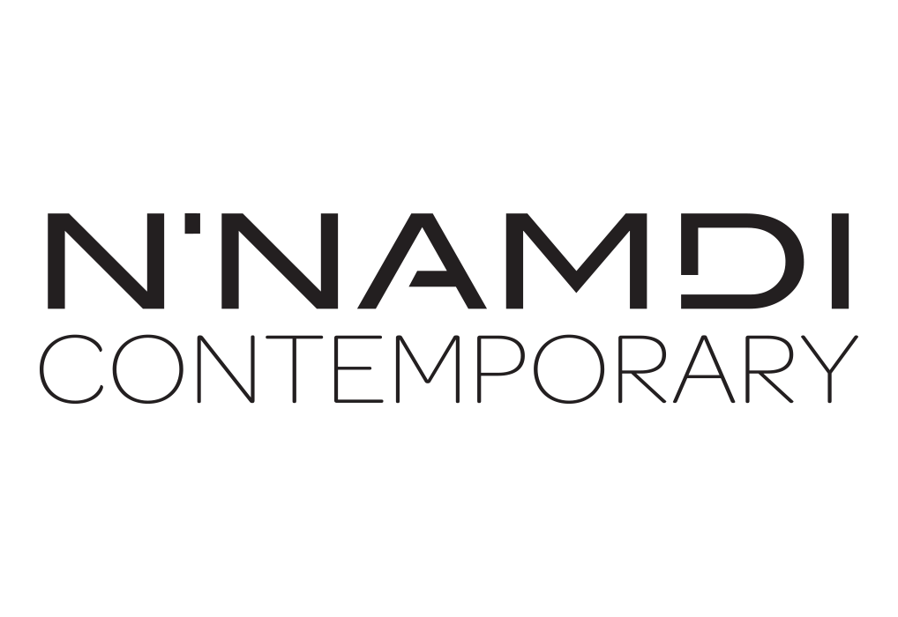

For further inquiries contact the N’Namdi Contemporary Fine Art Gallery  
786-332-4736 | 177 Nw 23rd St. Miami, Fl 33127 | [www.nnamdicontemporary.com](http://www.nnamdicontemporary.com)