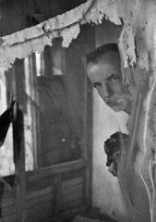

Alex Nyerges

is an internationally-award-winning photographer, curator, author, and photo historian who has exhibited across the United States and Europe.  His work is in collections in New York, Washington, D.C., Virginia, Ohio, San Francisco, Los Angeles, Palm Beach, Tampa, Richmond, Budapest, and elsewhere.  His work has been exhibited in Atlanta, Houston, Budapest, Richmond, Washington, D.C., among other places.

A native of Rochester, New York, the home of George Eastman and the Eastman Kodak Company, he grew up with a family tradition in photography and music.  He has been creating photographs in 35 mm; medium and large formats for more than thirty five years and digitally since 2003.

Seeking out the elements of beauty that surround us, so often unseen and neglected in the built and natural worlds, his work uses sunlight and its shadows to create works that are both modern and timeless.