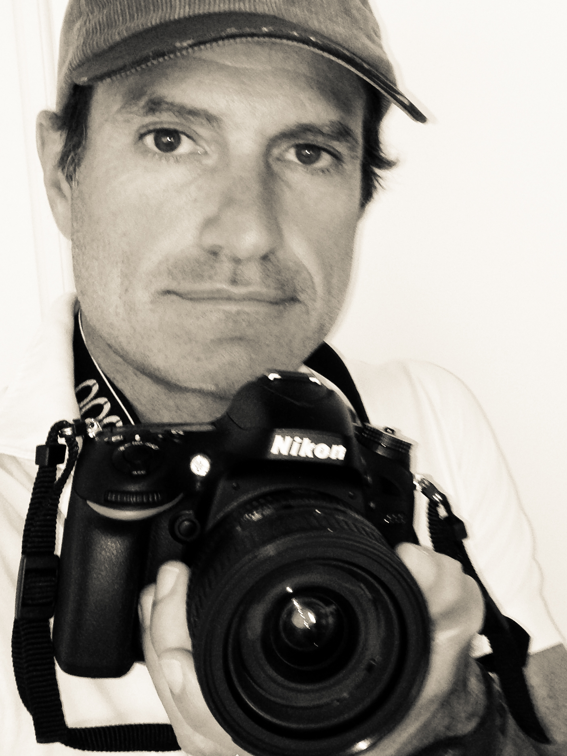

Carlos “Coco” Moni

is a self made artist born in 1967 in Buenos Aires, Argentina. He studied photography in the "Instituto Superior de Arte Fotografico" directed by Master Pedro Luis Raota.  Coco now lives in Key Biscayne, Florida since 2001. He found  in the Miami area the perfect spot to pursue his passions which are sports, music and photography.

What is always there but not always seen is the main discovery. I put my heart in every picture in search for the unseen beauty. I am always trying to bring something fresh and new to the scene. There is always another point of view, another way, another emotion, another color. The universe is flowing beauty everywhere. We only need an open mind and a camera. Beauty is in form, symmetry, lines, spaces, harmony, balance, repetition, breaking repetitions, proportions, composition. Everything should have it share. The light paints my reality trough the camera.  I love to share my images. I strongly believe words are not enough to describe how beautiful our world is.