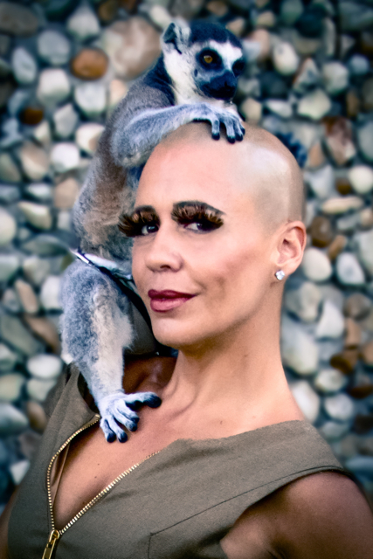

Milcho

was Born in France & raised in El Salvador. A video artist & photographer who has shown her art work both locally & internationally, a music video director who has been nominated for a VMA latino, a TV director who’s work has been nominated for EMMY’s & who’s directed the “Imagen Award” winning reality series for MTV tr3s "Quiero mis Quince” & "Quiero mi Boda.” Milcho is very active in the Music, Television & Art scene in Miami & gives back to the community by speaking to the kids in the public school system and colleges about the importance of being creative and fearless. In 2012 she gave a TEDx talk in El Salvador where she spoke about her creative process linked to her hair condition Trichotillomania; the urge to pick and pull her hair has been the topic of many interviews to bring awareness as well as her art pieces. Milcho lives and works in Miami Beach since 1987.

