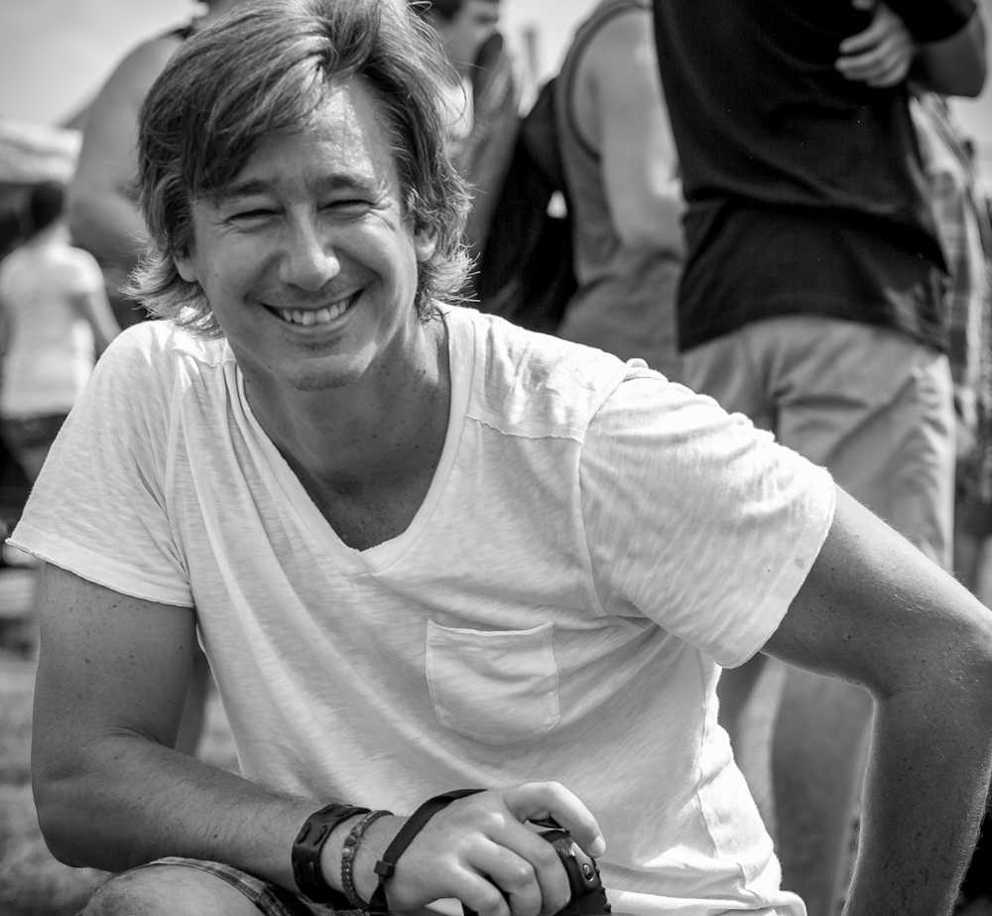

Manuel Mazzanti

Thirty years ago Manuel had the chance to shoot a Davis Cup tennis match in

Argentina. Learning how to play with the camera settings that afternoon influenced him greatly, turning photography into a lifelong companion. Add to this a natural perceptive ability born out of a passion for details and you have a photographer. Manuel’s passion for photography is combined with a two decade long marketing career, influencing in part, his conceptual narrative. His travels around the world have also been an important and meaningful way to show his versatility not only in his fine art street photography, but with his landscapes and cityscapes pieces as well.