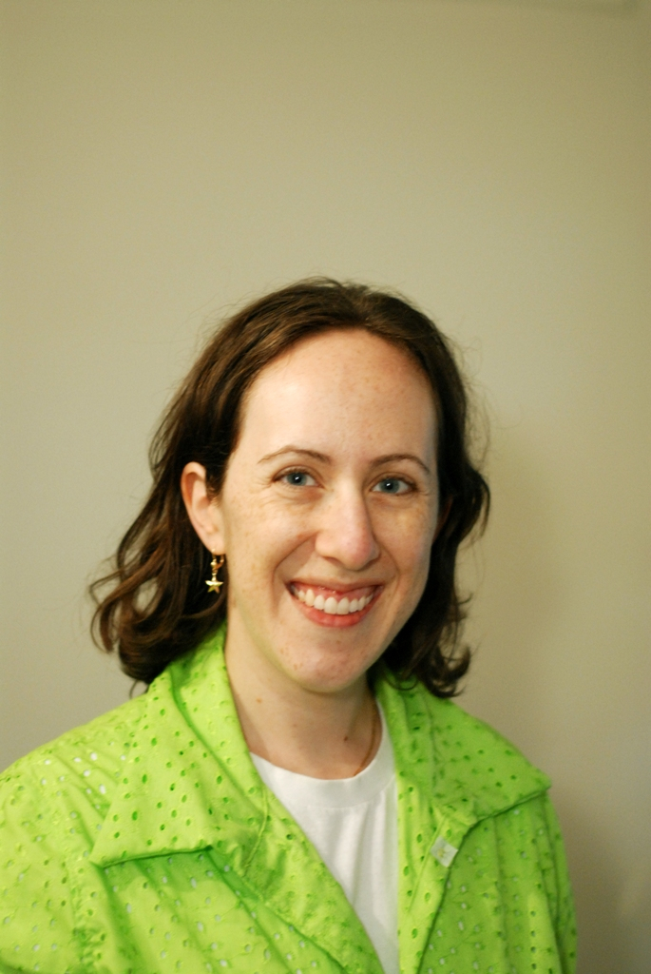

Sarah Krawcheck

Growing up outside Philadelphia Sarah Krawcheck earned a BS from Drexel University majoring in photography and MFA in photography from The University of Pennsylvania. In graduate school she met her future husband Matt, a fellow MFA candidate at Penn. After graduation Sarah and Matt married and lived in Florida, Vermont, and Kansas for various residencies and art teaching jobs before settling in Overland Park Kansas where they teach at the Art Institutes International-KC. Sarah is pursuing a newfound interest in sewing and applying her design sense to create wearable art. She is also developing new bodies of photo work and teaching photography.  Sarah and Matt plan to start a family and continue to advance their art careers.