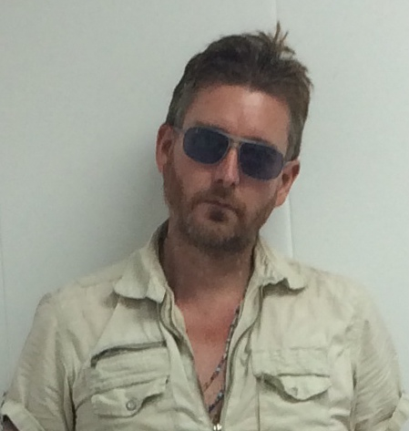

Michael Hunt was conceived at the original Woodstock Festival and born

in Honesdale, PA - the birthplace of the American railroad - in 1970. He

lives and works in Woodstock, New York.

Michael is a self-taught artist with no formal art education. Hunt's

sandblasted redwood paintings and photography is known as Cosmic

American Art - an outsider hybrid of Pop & Folk Art - which explores the

limits and myths of the American Dream.

After earning a B.A. in International Studies from Hofstra University's New

College, Hunt worked as a mover, truck driver, an AmeriCorps VISTA

volunteer in New York's Lower East Side, a mailroom supervisor at

Miramax Films and for the 2000 United States Census.

Michael has shown in over sixty group shows in North America including

CBGB’s 313 Gallery in New York City and the Wynwood Arts District Tour

at Basel Miami 2004. Hunt's sculpture "Heavenly Beatles" was auctioned

by Sotheby's.com in 2002. He successfully exhibited his work in two solo

shows at Zeke's Gallery in Montreal. Michael was the 2013 Artist-in-

Residence at Woodstock's Varga Gallery. He was the Visual Arts Director

at Mountain Jam X music festival at Hunter Mountain, NY.