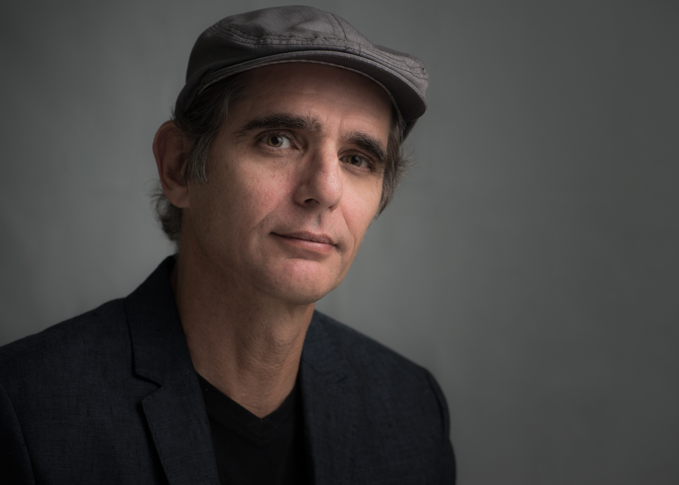

JORGE GOMEZ

I was born in the beautiful seaside town of Cienfuegos, Cuba in 1958. As soon as I put my hands on a SLR Camera from my Aunt, I was fascinated by it. Since then I have been passionate about photography.

Based in Miami, my work includes include travel, seascapes, landscapes, cityscapes, architecture, and fine art.

Although most of my images are of Miami and its surroundings my travels have also taken me to many places around the world and even as far as Russia, Eastern Europe and Turkey

With my photos I don't pretend to replicate reality, but more my interpretation of it

In order to achieve that goal I use several digital post processing techniques