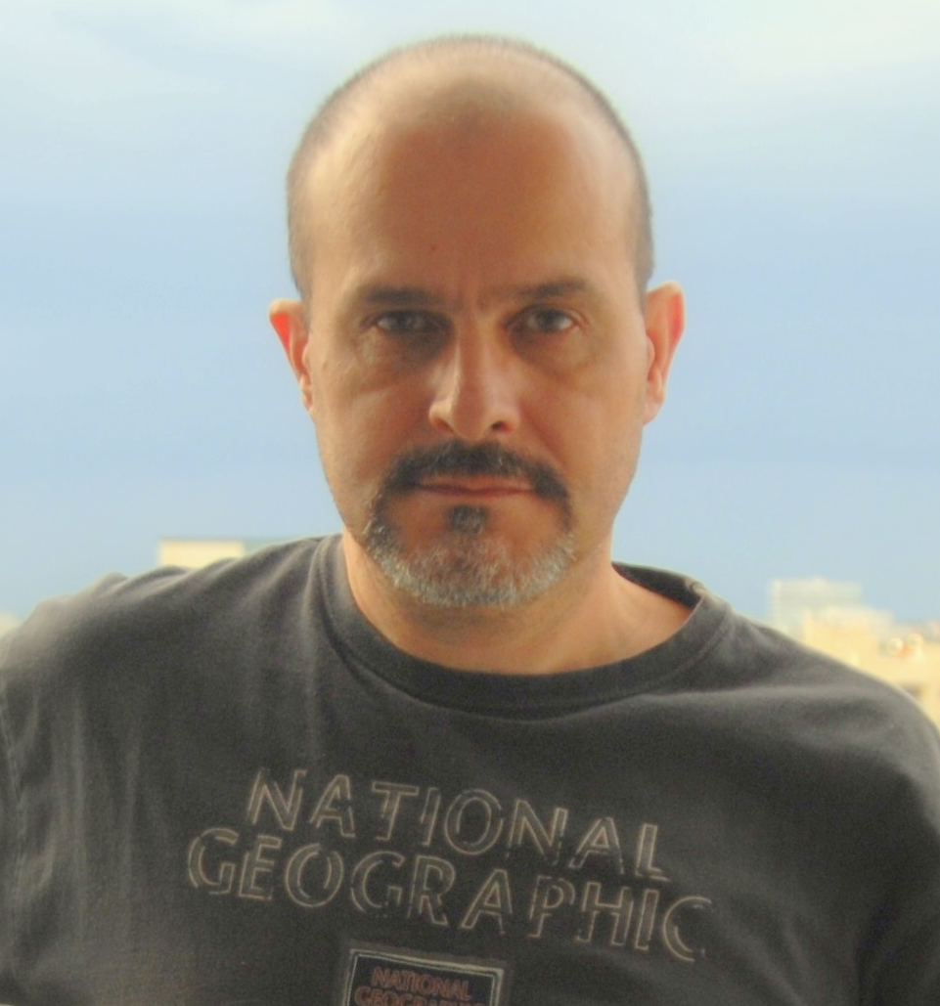
CURRICULUM VITAE
PATRICIO DIEZ BUTTY
Personal Data
Home Address: 2780 NE 183rd Street, Aventura, Florida 33160
Phone: 305-409-3380
E-mail: p10butty@gmail.com
Birthday: 01/13/1966
Gender: Male
Education
Bachelor of Arts in Business Administration
Belgrano University – Buenos Aires - Argentina

Retail Management Course 2011
Sales Management Course 2005
Austral University - IAE – Babson College of Boston Program

English: studied for more than sixteen years.
Spanish: native language.
Computer: Actual Systems
Skills & Work Experience
While performing in several service areas of different industries, I obtained expertise in: Marketing. B2B/B2C/B2G. Sales. Waste treatment and recycling. Gastronomy. Construction. Advertising and Media. Development, assemble social events. Representation of foreign companies. Material supplier for the Argentine Army. Consultant for the Argentine Army Communications Company.
Complementary knowledge:
Marketing. Environment. Logistics. Construction materials. Design. Equipment for Hotels and Restaurants. Dissertation. Photography. Digital Media. Instruction.
Achievements:
Development and maintenance of long-term relationships with customers.
Author
Author of “El Guardaespaldas Silencioso” the Silent Bodyguard. Dunken Publisher - 2006. This is the first spanish book about the art of knife fighting.
Summary of qualifications
2011-2012 Ecual Advertising – 360 Media
Sales Manager, maintaining the current customer portfolio and extending it permanently. In charge of the organization of public events. Supervision of them. Company Administration Assistant. (Cencosud / Carrefour / Standard Bank / Paseo Champagnat Mall / Tortugas Open Mall).
1998 - 2012 Representative and / or Dealer for Argentina:
SCEPTER: Canadian Company manufacturer of packaging for transporting fuel
SOURCE: Israeli Company manufacturer of military equipment (Hidratation Systems)
Racal Acoustics: British Company manufacturer of hearing accessories for radio communications equipments.
Thales Group: European conglomerate manufacturer of communications equipment.
Compton Webb Headdress: British Company manufacturer of berets, caps, hats and helmets for government institutions.
Pratt & Whitney: Canadian Company manufacturer of aviation engines.
Bell Helicopters: Helicopters maker.
1996-2012 TRI-ECO S.A. / Befesa S.A. / Recovering S.A.
Starting my business career offering the customer the waste treatment service in-situ and ex-situ. Oriented treatment of all types of waste generated by the industries. Including other services such as the installation of centrifuges in YPF for oil recovery.
My role was not limited to marketing, also includes counseling, staff training, billing, and certification. Generating new ventures such as plastic recycling, exporting electric transformers with PCBs, alternative fuels, etc. Reaching the Commercial Manager position.
Some of my clients: Toyota, VW, Ford, PSA Peugeot Citroen, Bayer, Rohm & Haas, Procter & Gamble, GlaxoSmithKline, Alcon Laboratories, Laboratorios Raffo, YPF, Eastman, Unilever, ESSO, Kluber, TFL SA, Mercedes Benz, Alusud, Solvay Indupa, Polisur, Voridian, Siderar (6 plants), Shell, Dapsa, Elf, Renner, Latasa (former Reynolds), Oiltanking, Petroken, Profertil, Sun Oil, Perez Companc, Minetti, Nestle, Agip, Eg3, ESSO, Dana (ex Armetal), Trinter, Telecom, Siderca, Comesi, Metalsa Argentina SA, Argentina Farloc SA, Pernod Ricard SA
2000-2001 Victoria Porcelain Inc.
Victoria Porcelain Inc. makes and sells China (porcelain) for hotels and restaurants use.They have their Head Office in Miami and the Manufacturing Plant in Venezuela.
Commercial Manager for Argentina. Market: Hotels and Restaurants
My duties included: Importation, registration of the mark, insertion of the product on the market, design of the brochures, marketing, teaching of courses for prolonging the life of the product, service replacement.
1990-1992 S.A.D.E. Ingeniería & Construcciones S.A. (Holding Perez Companc / ex General Electric)
Construction of the concrete structure of the Paseo Alcorta Shopping.
Responsible for the demolition of existing structures with the use of explosives. Coordinator of the Construction Inspection. Calculation of daily production of concrete. Responsible for Quality Control. Responsible for coordinating work progress of 6 foremen.
1986-2001 Professional Freelance Photographer.

