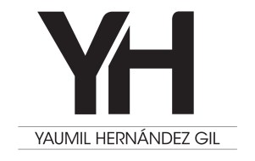

Yaumil Hernandez Gil, graduated from the National Academy of Fine Arts “San Alejandro” in Havana, Cuba. Yaumil has sixteen solo exhibits and more than fifty group shows. His work has been featured in fairs like Art Miami, Art Basel, Havana Biennial. His biggest solo exhibition “Mutatis Mutandis” was displayed in two part with critical success in two of the leadings galleries of Havana. Nowadays, “Mutatis Mutandis” is travelling around Mexico. His work is also part of a traveling group show throughout Mexican museums as part of a book written by Martha Zamora, Frida Kahlo’s biographer. Yaumil’s paintings appear in major collections in Mexico, Spain, Germany, Portugal, Canada, Israel, The Netherlands, the United States, France, Cyprus, Croatia, etc.